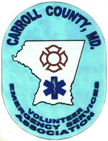

Carroll County Volunteer Emergency Services Association

Training Center Manager Employment Application

Last Name:

First Name:

Middle Name:

Street:

City: State: Zip:

Home Phone: Cell Phone:

Email address:

Social Security No.:

Vehicle Operators License No.:

Has your license ever been suspended or revoked in any state? No Yes

If yes, indicate which state, date and reason.

Have you ever been convicted of a crime (excluding minor traffic violations)? Conviction of a crime will not necessarily bar employment. Do not report any conviction for which records have been officially expunged. No Yes

If yes, please provide year of conviction.

How soon can you report to work?

Acceptable Salary Range:

Submit application by June 14, 2013 to ccvesa@comcast.net or mail to Carroll County Volunteer Emergency Services Association, 50 Kate Wagner Road, Westminster, MD 21157

